Name: Nitish Kumar

Mail:nitishkumarmalleboina512@gmail.com

Batch:125(10AM)

GitHUB: https://[github](https://github.com/nitishmalleboina/vcube-tasks).com/nitishmalleboina/vcube-tasks

**Task on S3 Cross-Region Replication(CRR)**

Amazon S3 now supports cross-region replication, a new feature that automatically replicates data across AWS regions. With cross-region replication, every object uploaded to an S3 bucket is automatically replicated to a destination bucket in a different AWS region that you choose.

create bucket in S3: This bucket is taken as source bucket.

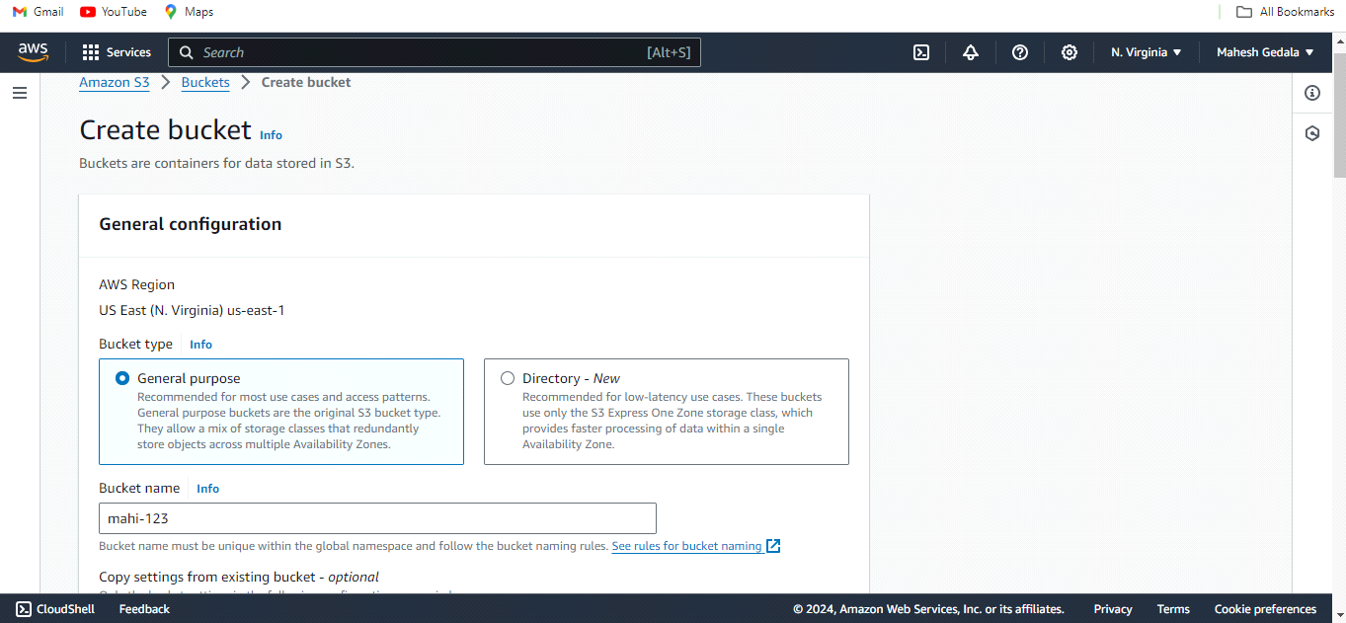

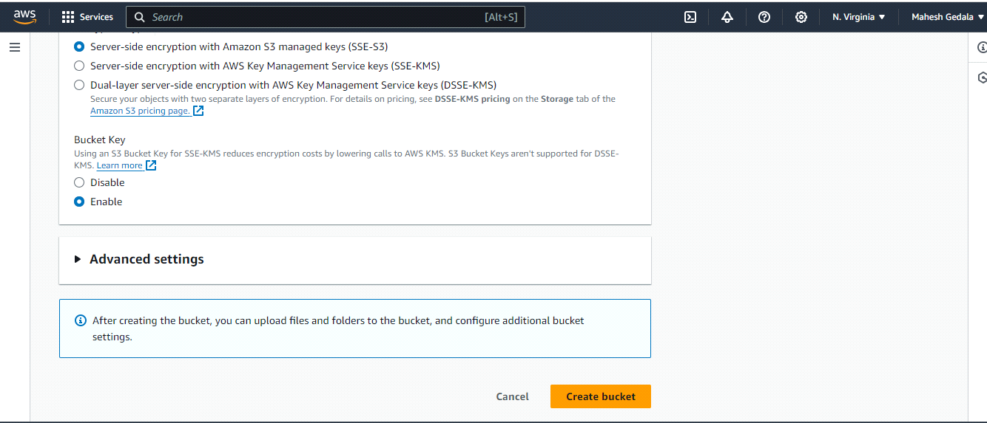

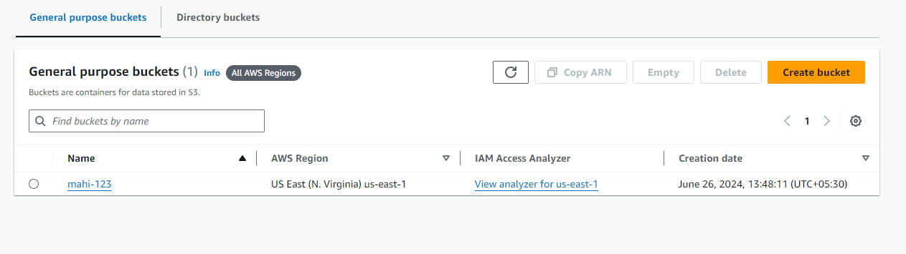

upload files in source bucket;

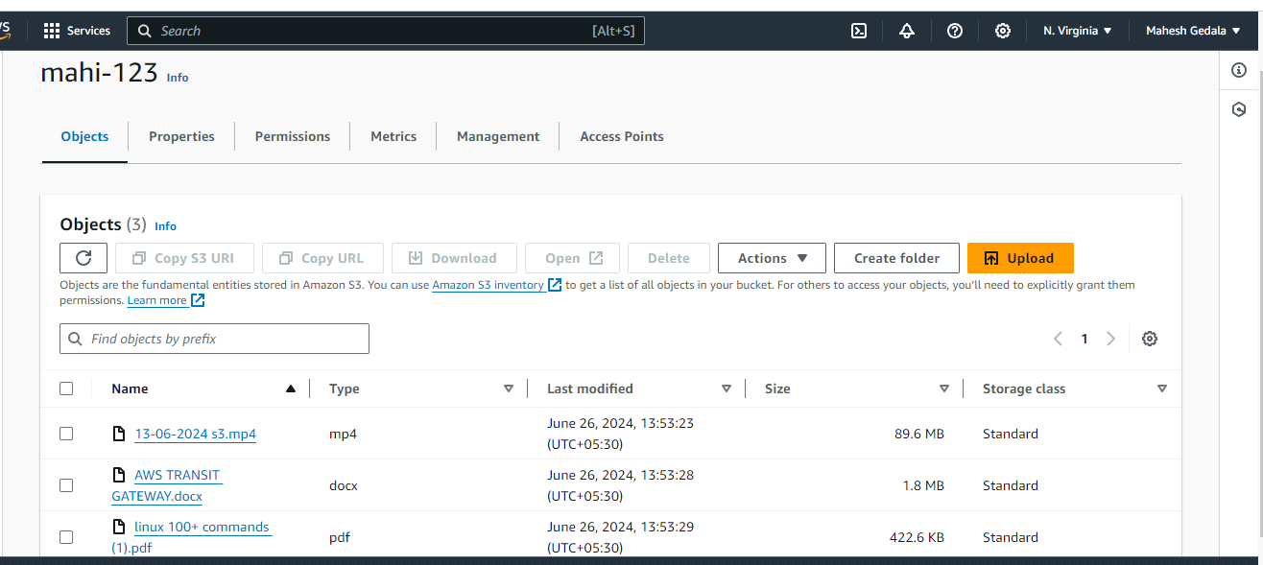

**Create Destination bucket in different region not same region:**

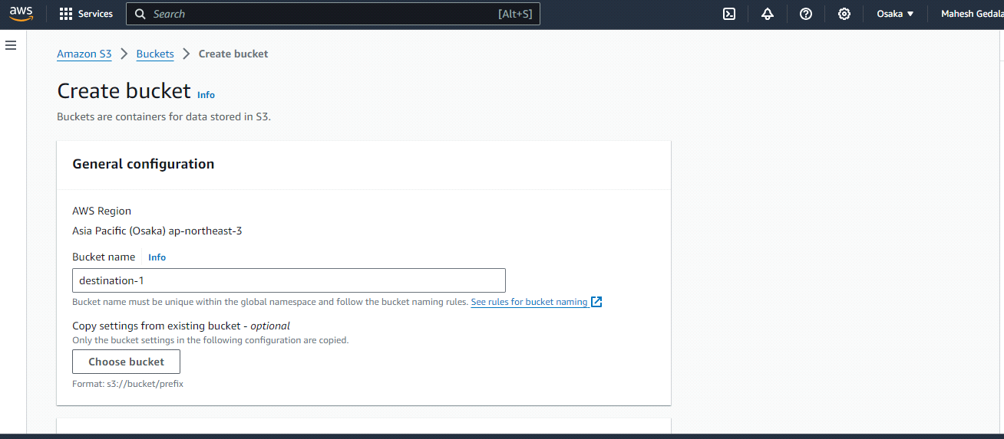

**Here to enable the bucket versioning.**

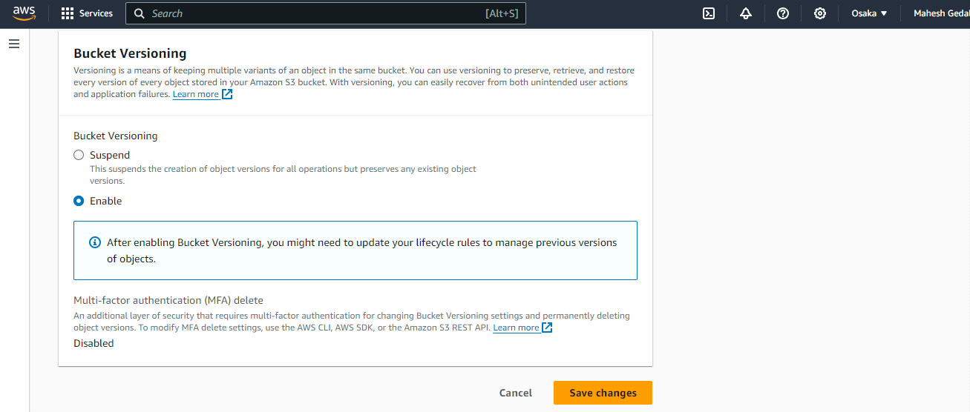

**Here the Destination bucket is empty:**

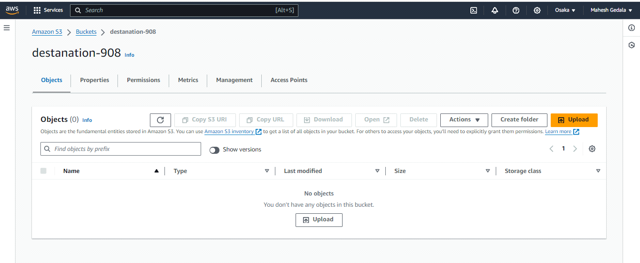

**Go to Management and click on replication rule:**

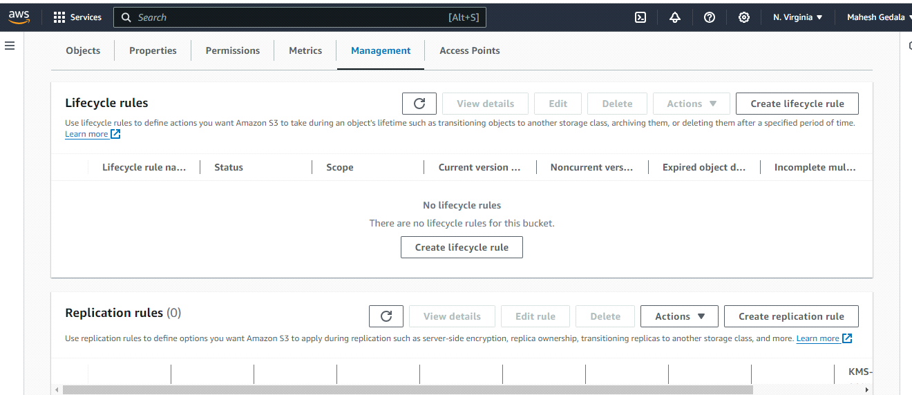

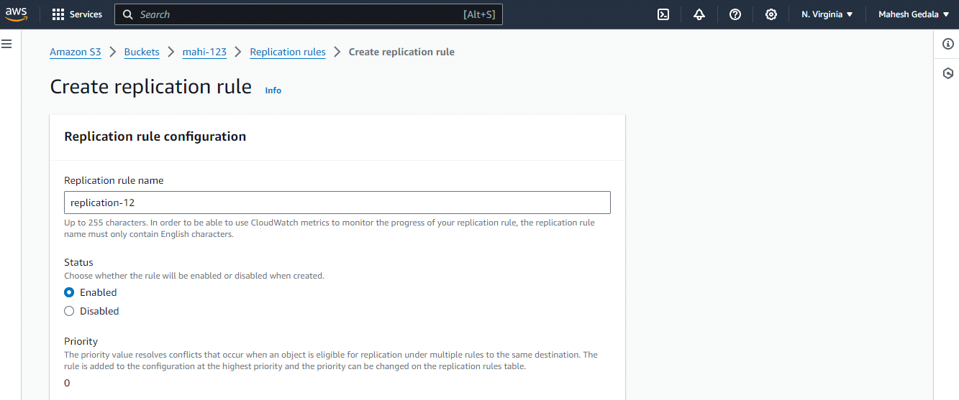

**choose apply to all objects in the bucket:**

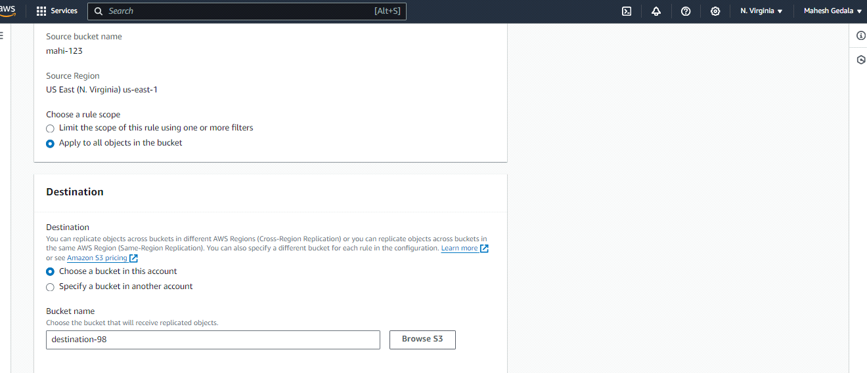

**Yes replication.**

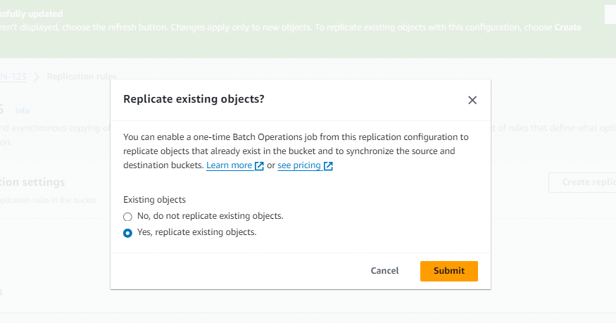

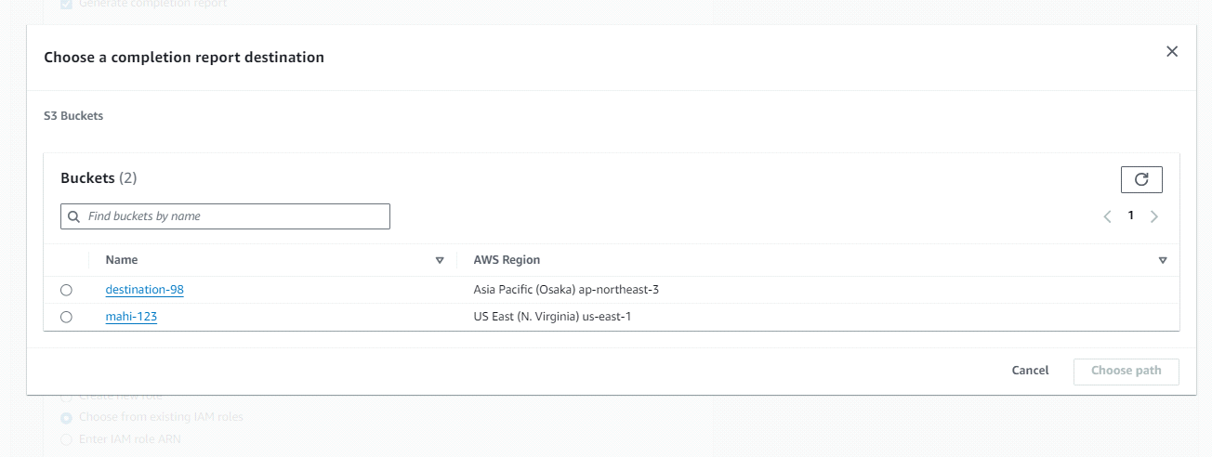

**here browse Destanation bucket and create new role.**

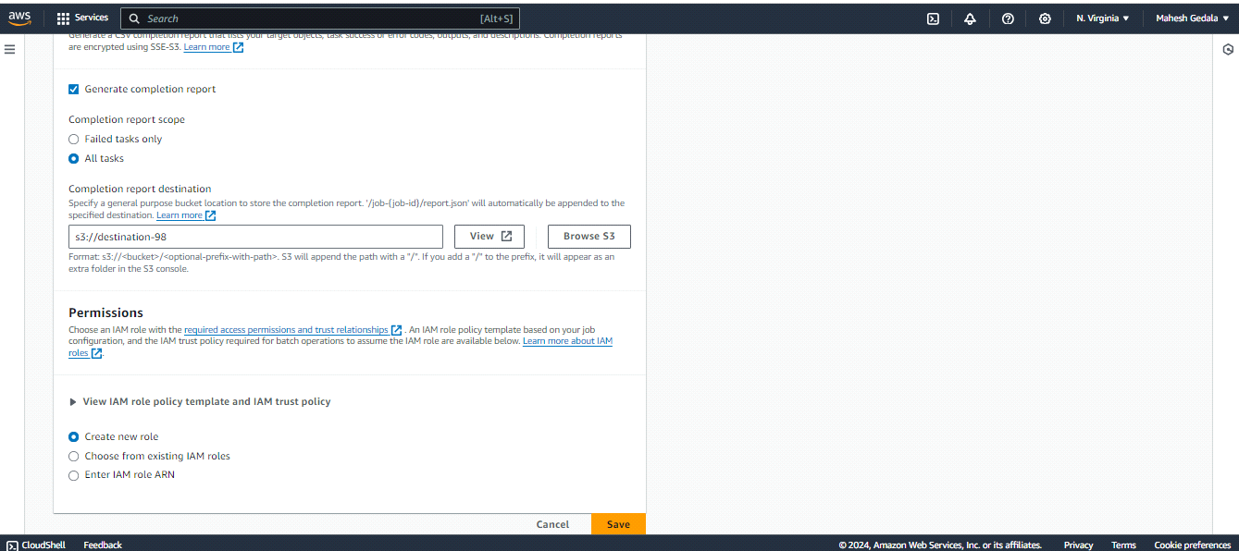

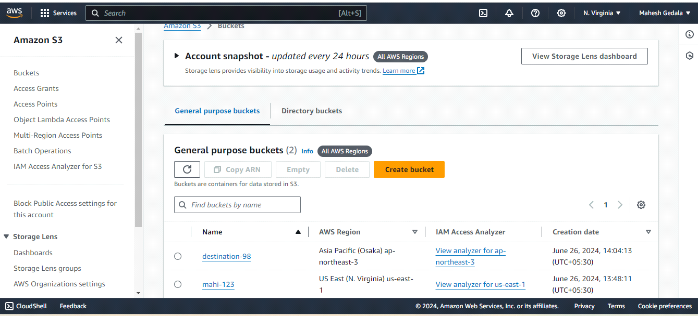

**Here data replicate to the destination bucket:**

